Task Priority sorting algorithm

Algorithm Overview:
This algorithm sorts tasks by priority using a scoring system. The scores are based on the task’s priority status, the due date, its taskStatus, its tags, and its updates. The base score of each task is based on its priority status. Tasks with a closer date get a boosted score. Tasks that are completed or in review get their score reduced. Tasks with certain tags get a boosted score. Tasks that have been recently updated get a boosted score.

Step-by-step breakdown:
- Step 1: Build priority Map.
Initial score is set by multiplying the current priority status by 10
- Step 2: Does the task have a due date?
If the task does not have a due date, then skip it.
If the task has a due date, then give a score based on how close the due date is to the current date.
- Step 3: Check the task status.
If it is ‘DONE’ or ‘FINISHED’ decrease the score by 50 or 15, respectively.
- Step 4: Check the tag.
If the tag matches ‘blocker’, ‘critical’, or ‘urgent’ then increase score by 8.
- Step 5: Check if the task was updated in the last 24 hours.
If it was then the score is increased by 8.
Function returns the score as an integer.

Diagram:
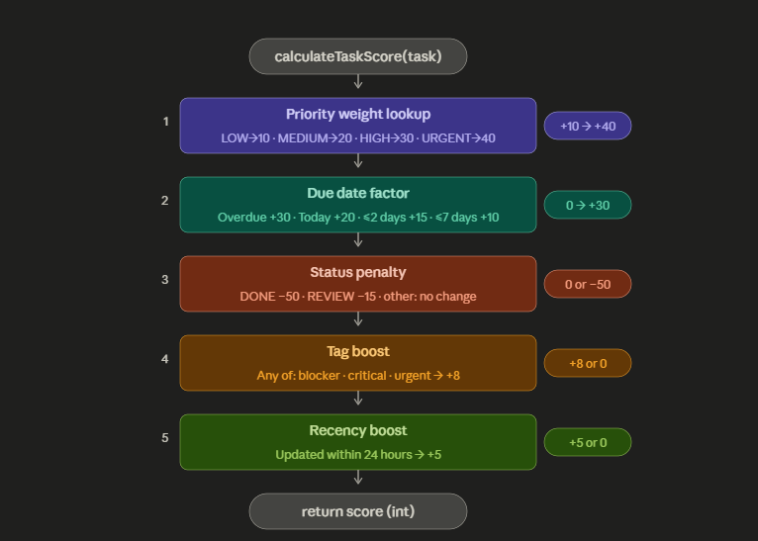

Key Insights:

Priority weight map:
This is a table that maps an enumeration to a priority weight. A hashmap is a data structure that stores key and value pairs, you can use a key to look up the value it is connected to. If the priority does not match any key, it returns a zero instead of throwing a nullpointerexception.

Due date factor:
Converts the due date into days remaining. A negative result means the task is overdue. The close the deadline, the higher the score that gets added.

Status penalty:
Completed tasks get their score reduced a lot to take them to the bottom of the list. Taks in their ‘Review’ status get a smaller reduction in score.

Tag boost:
Uses a stream to check if the tags match certain keywords. If they match one tag they earn a small score.

Recency Boost:
Tasks that were updated recently get a small score boost.

Reflection:

